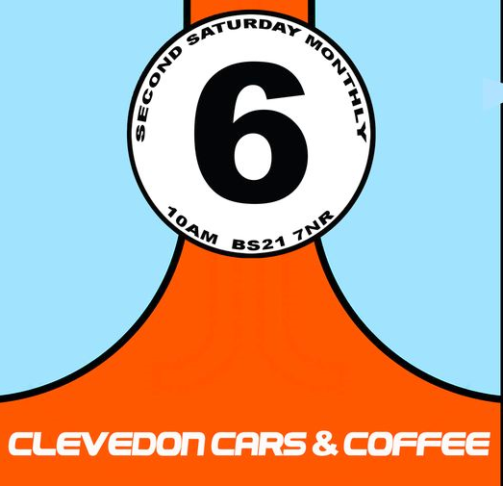

Clevedon Cars & Copters Event
24 May 2025 10.00AM – 2PM

We have pleasure in inviting you to our special annual Clevedon Cars & Copters event being held at the Helicopter Museum!
We have a huge range of vehicles attending and we would love for you to join us in exhibiting your pride & joy!
We have classic, vintage & supercars, bikes, themed vehicles, military, hot rods, rally cars and even special attendees; the Vampire Jet Car and dragsters!
This is all set around the world famous Helicopter Museum!
We even have our favourite band, Groove Jacks providing the entertainment!

Registration for the event is £5 per vehicle, which includes a CC&C window vinyl you will be given on the day

Event information
Date | 24 May 2025
Time | Arrival for exhibitors is between 830-930am and depart after 2pm  Due to the public entry opening at 10, all exhibitors must be in place by 945am please – sadly we cannot accommodate late arrivals and the exhibitor gate will be closed at 10am  Exhibitors need to be able to stay for the full event until at least 2pm (except for emergencies when cars will be escorted out by marshals)  *We can only accept pre-bookings for exhibitors as there is no exhibitor entry on the day*
Address | The Helicopter Museum  Locking Moor Road  Weston Super Mare BS24 8PP
Museum entry | Exhibitors have a reduced entrance fee of £8 to the museum which can be purchased on the day
Refreshments | Exhibitors have exclusive access to the Museum cafe as well as catering available on site
Additional information | Due to the site, unfortunately no dogs are allowed.  Guide dogs/assistant dogs are welcome

Please complete the following to book in your vehicle and our events team will be in touch shortly to confirm you are booked in.
Please return to CCC.events@yahoo.com
(please also use email for any queries)
Name
Telephone
Email
Vehicle Make, Model & year
Vehicle Reg number
Are you coming as part of a club?
If yes, please state which club and contact details for the club so we can aim to park you together
Please pay £5  (cost is £5 per vehicle)  State your name and vehicle registration on the notes.  (Fee is non refundable) | Please pay £5 to Clevedon Cars & Coffee**
Confirmation of your unique booking number to be quoted on the day  Will be confirmed to you on receipt of the payment & completed booking form via email  Thank you! | Number: _________________________

**PAY AT: https://pay.sumup.com/b2c/QK1VQRIT

